**Project Name:** Vehicle Investigation System

**Github Link:** https://github.com/projectsforstudents2022/Vehicle_Investigation_System.git

**Why was this project created?**

The user's request for their stolen car will be handled by the vehicle investigation system, which will also create a special complaint id for registration. By utilizing this complaint id for their vehicle and the place where their vehicle has been found, users will be able to access details on the progress report. Even if users lose track of their complaint ID, they can retrieve it by inputting their car number and the facts that go with it. Each user must have a working login ID and password in order to use this system, which only allows users with complaint ids to check the status of their investigations.

**What problem is it solving?**

This initiative focuses entirely on vehicle registration as well as on the registration number date to locate stolen vehicles. The owner of the car should register the stolen vehicle information before searching for the stolen autos. If you forget your vehicle's registration number, it also provides information about it. This makes it easier to purchase used cars because you can verify the vehicle's condition before buying and changing the owner.

**Entire explanation of project**

* **PROPOSED APPROACH**

By utilizing this complaint id for their vehicle and the place where their vehicle has been found, users will be able to access details on the progress report. Users must register their vehicle by providing all relevant information, including the model, brand, vehicle number, date of purchase, last usage, and the location from which the vehicle was stolen, in order to receive report details and a complaint id. Even if users lose track of their complaint ID, they can retrieve it by inputting their car number and the facts that go with it. Each user must have a working login ID and password in order to use this system, which only allows users with complaint ids to check the status of their investigations. In order to make the system more interactive, the admin panel has also been given the ability to add photographs and define car model numbers, allowing users to see the model of their vehicle while registering a complaint. To create a completely interactive and responsive system, scripts have been created in a more efficient way to respond to user queries even when there is a slow internet connection. Designing is improved by using the relationship between tiles and tables and by doing away with data redundancy. Users will be given access to the brand name and model of their automobiles, as well as digital images of them, to make the vehicle choosing process easier for buyers. To ensure that each complaint id is distinct from the others, the notion of triggers and sequences has been added on the back end, which eliminates the need for human interaction when setting the complaint id.

* **RESULT**

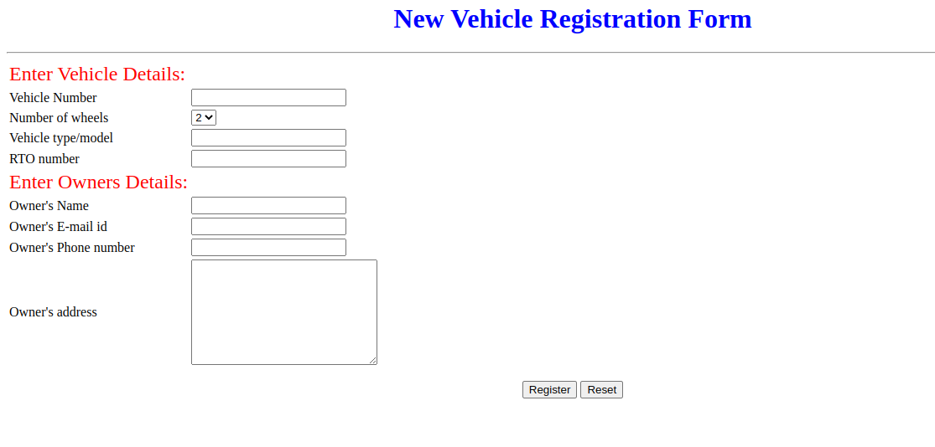

**CONCLUSION**

It is a real-time project that would be beneficial to the general people who are having issues with the current manual system, which requires that the driver of the vehicle carry the necessary documentation. The public would find it simpler with the suggested approach because it would be an automated process. therefore reducing the stress placed on the general populace. The documents wouldn't be lost or utilized improperly as they wouldn't need to be carried. Consequently, the documents' security is guaranteed.